RABR LESSON PLANS
English National Curriculum 2016
Geography EN4-5b
Year 4; Lesson time 1 hour
River meanders & oxbow lakes
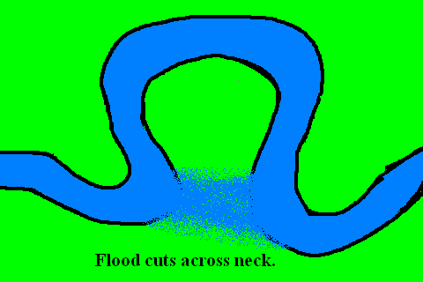
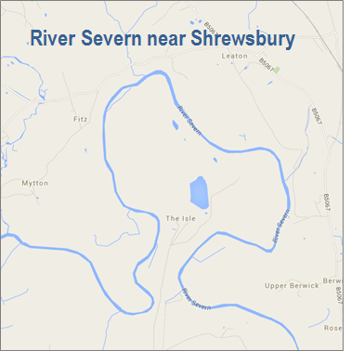

Race Flightpath
Welshpool to Shrewsbury

Geography: Meandering Rivers and Oxbow Lakes

Time  (mins) | Lesson Phase | Details
5 | Warm-up | Log on to your classes balloon account and put your name on your balloon. What is the definition of the word ‘meander’ Is it easy to see a meandering river? Ask the children to draw a meandering river. Can a mountain river meander?
10 | Introduction | Lesson objectives  1. How land gradient is a major factor in meanders  2. Meandering rivers are slow rivers too  3. Slow rivers are more likely to flood  4. Oxbow lakes are created from meanders  Key words: gradient, slope, meander, oxbow lake
5 | Brain Activation | You now know what gradient means, but how do you measure a gradient? So what will be the typical gradient of a mountain stream against that of the River Severn in Shrewsbury, say?
10-15 | Body of new information | We will show the children how flat gradients can create meanders and how some of those meanders can ultimately form oxbow lakes. We will also discuss what stops all meanders becoming oxbow lakes? When river flooding occurs, where has the water comes from
5-10 | Practice and review | How can we work out the gradient of the River Severn between Welshpool and Shrewsbury?  Do you think the River Severn floods and where does all the water come from?
10 | Independent Practice | Where is your balloon now and how many river meanders can you count?
5 | Review | Does everyone feel they now understand why rivers sometimes meander and what is their gradient

